**Explorations of the effect of tolerance levels and group sizes on the level of segregation**

**Introduction**

Agent-based modeling is a powerful technique used to simulate complex systems by modeling the behavior of individual agents and their interactions. In this study, we explore the effect of tolerance levels and group sizes on the level of segregation using the Schelling model. The Schelling model is a well-known ABM that simulates residential segregation and can be used to examine the factors that contribute to segregation. The decision rule for agents to move is based on their tolerance level, and if the proportion of same-group neighbors is less than the tolerance, the agent will move to a random empty cell in the grid. We generated a 20x20 grid with 200 agents and ran the simulation for 50 iterations, testing two levels of tolerance and two different group sizes. The results were measured using the Schelling index, and the findings were analyzed and compared. By examining how different factors affect the level of segregation in the model, we hope to gain insights into how segregation can be reduced in real-world settings.

**Methods**

The decision rule for the agents is based on the Schelling model. If the proportion of same-group neighbors (including itself) is less than the tolerance level, then the agent will move to a random empty cell in the grid. Additionally, the agents will be considered unhappy if the proportion of same-group neighbors is less than the tolerance level, and they will move to a random empty cell until they find a new location where they are satisfied. The study will explore how the decision rule, along with the tolerance levels and group sizes, affect the level of segregation in the grid. The group sizes here are 100 agents for equal grouping and for unequal grouping 150 and 50 agents are selected.

**Results**

1. Equal grouping Low Threshold: Plot of time vs segregation for a simulation with a low tolerance level and equal-sized groups.

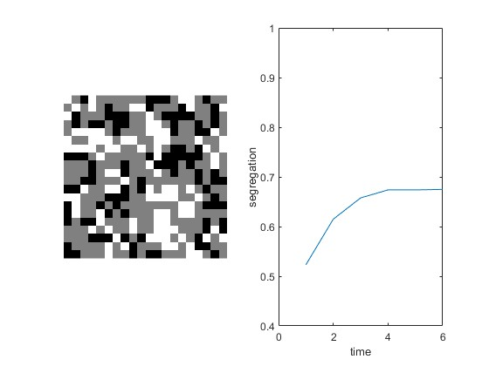

1. Unequal grouping Low Threshold: Plot of time vs segregation for a simulation with a low tolerance level and unequal-sized groups.

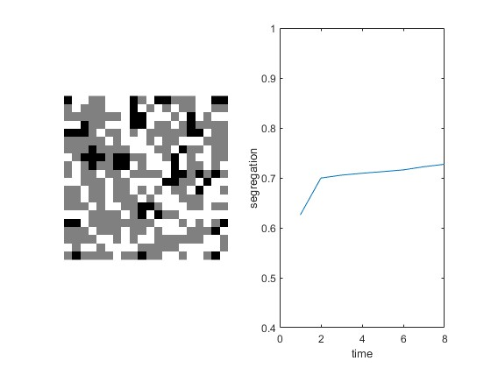

1. Equal grouping High Threshold: Plot of time vs segregation for a simulation with a high tolerance level and equal-sized groups.

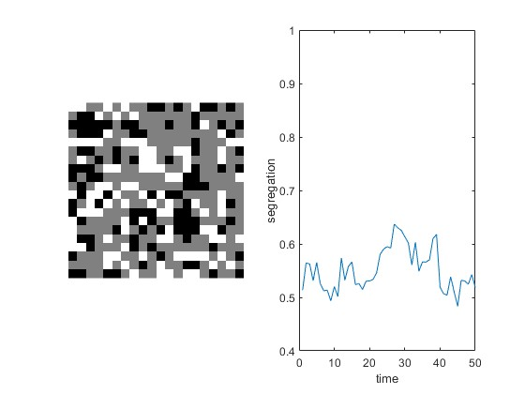

1. Unequal grouping High Threshold: Plot of time vs segregation for a simulation with a high tolerance level and unequal-sized groups.

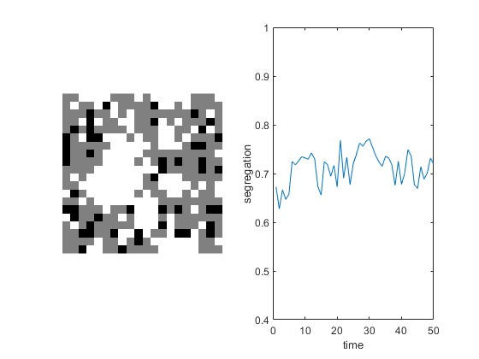

**Discussion**

The results of our study provide insights into the effects of tolerance levels and group sizes on the level of segregation in a 2D grid. The simulations show that the level of segregation is influenced by both tolerance levels and group sizes. When the tolerance level is low, agents are more likely to move to a different location if their immediate neighbors are not from the same group. This leads to a high level of segregation in both equal and unequal group sizes. In contrast, when the tolerance level is high, agents are more likely to tolerate living with neighbors from different groups, leading to a lower level of segregation in both equal and unequal group sizes.

The unequal group size simulation shows that a higher proportion of agents in one group can lead to greater levels of segregation, especially when the tolerance level is low. This is consistent with real-world observations where areas with high levels of social segregation often have a higher proportion of one ethnic or socio-economic group (Wikipedia, 2023).

Our findings are in line with previous research that highlights the importance of tolerance levels and group sizes in social segregation. The Schelling model has been used in various studies to simulate social segregation in urban areas and demonstrate the effects of different factors on the level of segregation (Fossett & Dietrich, 2018). Our study adds to this body of literature by specifically examining the impact of tolerance levels and group sizes on segregation in a controlled environment.

Overall, our study highlights the importance of tolerance levels and group sizes in social segregation. By understanding these factors, policymakers and urban planners can develop strategies to promote diversity and reduce segregation in cities. For example, policies that promote mixed-income housing and support the integration of different groups can help to create more inclusive and diverse communities (Wikipedia, 2023).

**References**

1. Fossett, M. & Dietrich, D. R. (2018). Testing the Schelling segregation model. Sociological Science, 5, 295-310.
2. Wikipedia. (2023). Social segregation. Retrieved April 7, 2023, from https://en.wikipedia.org/wiki/Social_segregation